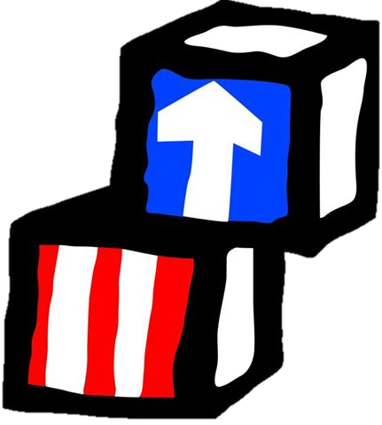
Head Start / Early Head Start
2021-2022 Annual Report
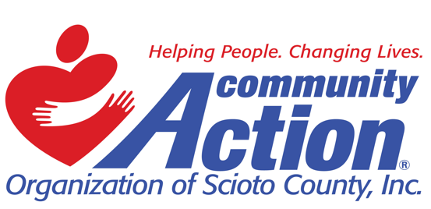

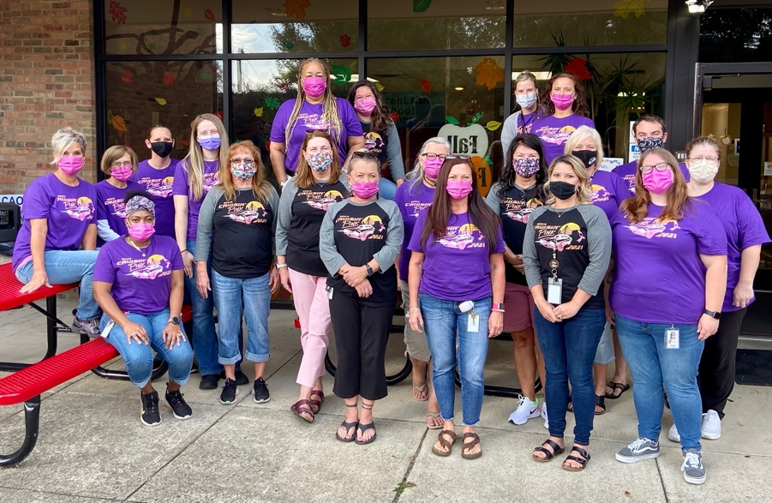
Program Description and Highlights
COVID continued to disrupt our 2021-2022 school year, but our technology skills and capabilities continue to grow. We are proud of our staff’s adaptability to move between in-person services and virtual services while maintaining their relationships with families. Staying connected with our children and families was our priority. We continued to send newsletters, books, activities, and supplies. Our staff is presently 98% vaccinated.

We have added a YouTube page. Our page contains people from our community reading some of our favorite books! The books match books that we have sent home with children and titles that are in our classrooms. You will also find cooking videos on our page. We have teamed with our Extension Office through the Ohio State University.

CAO of Scioto County Head Start/Early Head Start operates a public-funded preschool program for predominately low-income children, age birth-5, residing in Scioto County who meet eligibility guidelines. Serving the 614 rural square miles of Scioto County, Ohio, Scioto County CAO Head Start/Early Head Start operates eight centers and home base services with an enrollment of 422 children. Our Centers and enrollment numbers are listed below:

Center | Classroom | Students Served | Step Up To Quality
Highland Head Start | 7HS classrooms | 72 preschool children | 5 star
 | 1 EHS classroom | 8 infants & toddlers
Carousel Center Head Start | 3 HS Classrooms | 45 preschool children
Farley Square Head Start | 1 HS Classroom | 20 preschool children
Miller Manor Head Start | 1 HS Classroom | 20 preschool children
Northwest Head Start | 1 HS Classroom | 20 preschool children
West Portsmouth Head Start | 2 HS Classroom | 38 preschool children
Kendall Heights Head Start | 1 HS Classroom | 15 preschool children
Sciotoville Head Start | 1 HS Classroom | 18 preschool children
Head Start Home Base | 4 HS Home Visitors | 60 preschool children
Early Head Start Home Base | 11 EHS Home Visitors | 106 infants & toddlers
Total Funded Enrollment |  | 422
Scioto County CAO Head Start participates in Ohio’s Step Up to Quality rating system for childcare centers.

Scioto County CAO Head Start had 92 employees for the 2021-2022 school year: 65 full-time and 27 part-time employees.

2021-2022 School Year Enrollment
 | Head Start | Early Head Start
Funded Enrollment | 308 | 114
Average Daily Attendance | 77.1% | 75.7%
Accumulative Total Children/Pregnant Women Served | 287 | 209
Total Families Served | 189 | 185

Eligibility | Head Start | Early Head Start
Income 100% of Poverty Level | 209 | 93
Public Assistance (SNAP/TANF/SSI) | 43 | 16
Foster Children | 4 | 6
Homeless | 1 | 3
Over Income | 9 | 5

Children receiving physicals and dental as a percentage of all children served during 2021-2022 School Year:
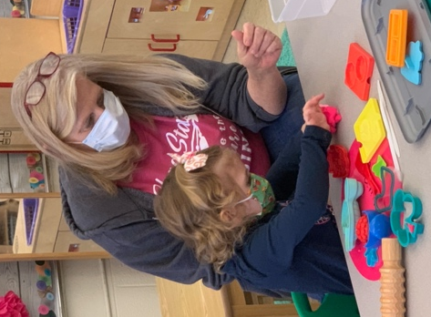
Head Start Early Head Start
Physicals 248 / 87.3% 182 / 87.1%
Dental Exams/Screenings 170 / 59.8% 137 / 65.6%

Average monthly enrollment was down for the year because of two factors. First, we have had trouble finding qualified staff. We are working with our Agency Workforce office and our local university. Second, to maintain COVID safety protocols we lowered enrollment numbers in several centers. We are expecting to be at full enrollment for fall 2022.

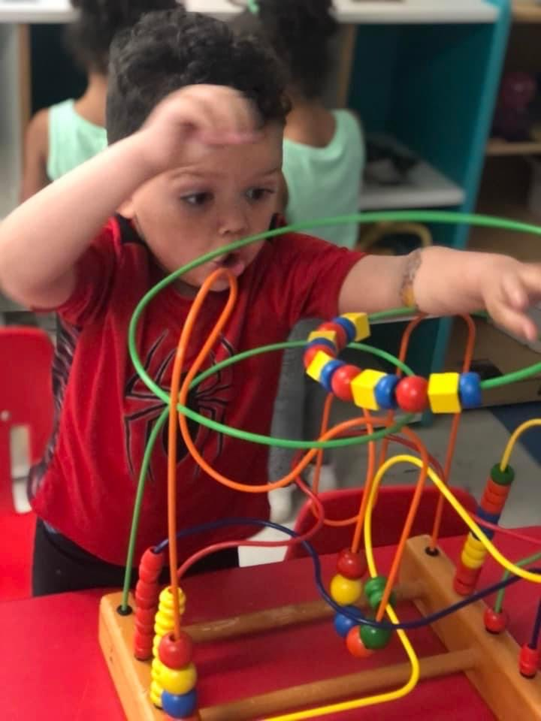
Average Monthly Enrollment:

Head Start Early Head Start
July 2021 --- 114 / 100%
August 2021 189 / 61.4% 114 / 100%
September 2021 183 / 59.4% 114 / 100%
October 2021 227 / 73.7% 114 / 100%
November 2021 232 / 73.7% 114 / 100%
December 2021 223 / 72.4% 114 / 100%
January 2022 237 / 77% 114 / 100%
February 2022 237 / 77% 114 / 100%
March 2022 237 / 77% 114 / 100%
April 2022 239 / 78% 114 / 100%
May 2022 239 / 78% 114 / 100%
June 2022 ---- 114 / 100%

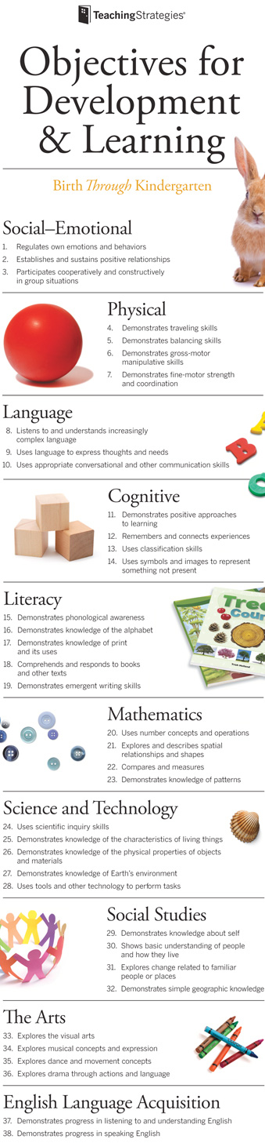
School Readiness
School Readiness means that children are ready for school, families are ready to support their children’s learning, and schools are ready for children. All Head Start and Early Head Start programs are required to establish school readiness goals, which are defined as “the expectations of children’s status and progress across domains of language and literacy development, cognition and general knowledge, approaches to learning, physical health and well-being and motor development, and social and emotional development that will improve readiness for kindergarten goals” and that “appropriately reflect the ages of children, birth to five, participating in the program” (Head Start Act, 2007). Head Start/Early Head Start views school readiness as children possessing the skills, knowledge, and attitudes necessary for success in school and for later learning and life.

Scioto County CAO Head Start/Early Head Start has established five School Readiness Goals around the five essential domains of language and literacy development, cognition and general knowledge, approaches to learning, physical health and well-being, motor development, and social and emotional development as outlined in the Head Start Framework. These goals are imbedded in our Five-Year Program Goals. Attributes were developed under each goal to help focus definition and clarity.

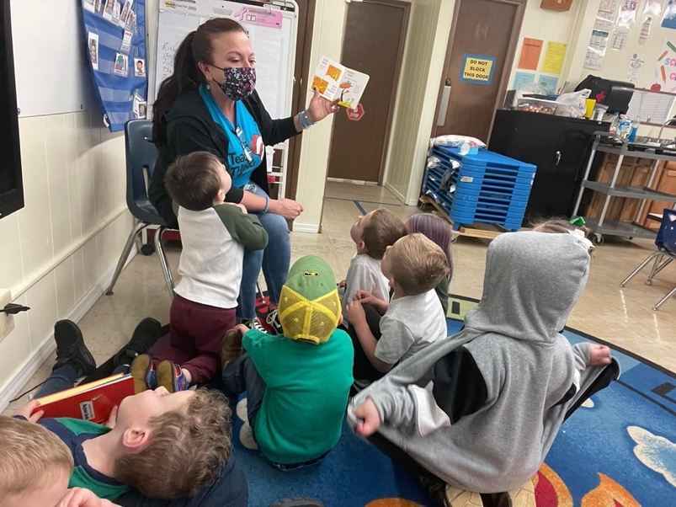
Scioto County CAO Head Start/Early Head Start uses Teaching Strategies Gold to assess children and collect data around our goals. Data is aggregated and analyzed three times during the school year on November 15th, February 15th, and May 15th. Early Head Start observes a fourth data collection cycle on August 15th. The program plan four in-service days where data is discussed and analyzed giving staff the opportunity to gain clarification, plan and dig deeper into the information we have gathered about our children and families. Data is used to develop program improvement including staff development, resource allocation, and program planning. Data is shared with families and program partners regularly.

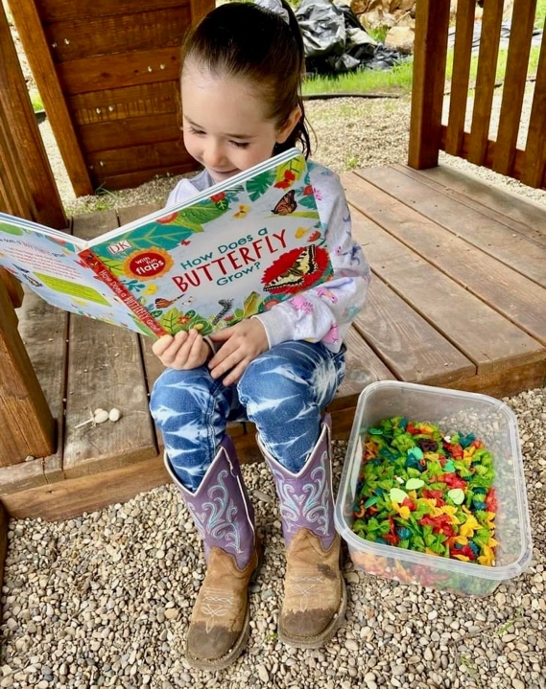
As early childhood professionals our goal is that children leave our program excited about learning and that our families are ready to be advocates for their children supporting them throughout their educational experiences.

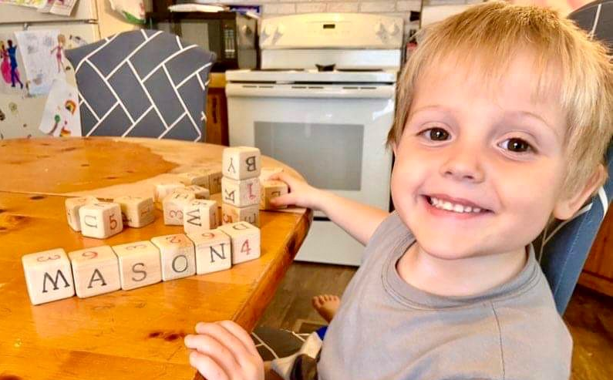

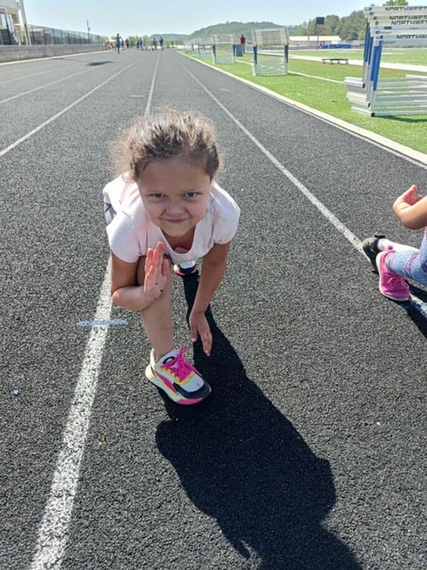
Program Goals

Our School Readiness Goals are embedded in Goal 1 of our Five-Year program goals.

Goal #1 - Children will have the social and educational foundation to be self-assured, life-long learners, while building meaningful relationships. (School Readiness Goals)

Objective 1 Approaches to learning 2021-2022 Gains 21%
Using Conscious Discipline strategies daily, children will identify and manage emotions with increasing independence.

Objective 2 Social and Emotional Development 2021-2022 Gains 23%
Children will demonstrate increased ability to create and sustain warm trusting relationships with adults and children.

Objective 3 Language and Communication 2021-2022 Gains 31%
Children will be engaged literacy learners through intentional teaching practices and experiences to develop a joy of books and reading.

Objective 4 Cognition 2021-2022 Gains 28%
Children will develop math and science concepts and skills through daily learning opportunities and intentional teaching strategies.

Objective 5 Perceptual, Motor, and Physical Development 2021-2022 Gains 20%
Children will have daily opportunities and supports to develop both fine and gross motor skills during a variety of learning experiences.

Our other goals center around wellness and growing our program. As we move forward and out of the pandemic we are working with our staff, families, and partners to grow our program, strengthen our relationships and support the children and families we are proud to serve.

Goal #2 - Children, families, and staff will be provided supports around the Seven Dimensions of Wellness: Physical, Social, Emotional, Spiritual, Environmental, Occupational, and Intellectual.
Objective 1
Child wellness: Children will develop emotional self-regulation and maintain healthy connections with peers and familiar adults.
Objective 2
Family Wellness: Families will receive support and empowerment to set goals to address 7 dimensions of wellness, family challenges and build self-sufficiency.
Objective 3
Staff Wellness: Early Childhood Educators must be well to do well. Program will develop a wellness plan to support staff with their individual needs.

Goal #3 - Strengthen families. – Empower families to be pro-active in child’s success in school and beyond.
Objective
Staff will use multiple strategies to build and maintain relationships with families.

Goal #4 - Scioto County CAO Head Star/Early Head Start will be recognized as the area leader for early childhood education programs.
Objective 1
Systematic changes to program operations to provide seamless transition between program options serving birth to age five.
Objective 2
Program will maximize use of technology and marketing to engage community or families.

Early Head Start Children transitioning to Head Start in August 2022: 24
Head Start Children transitioning to area public schools in August 2022: 98
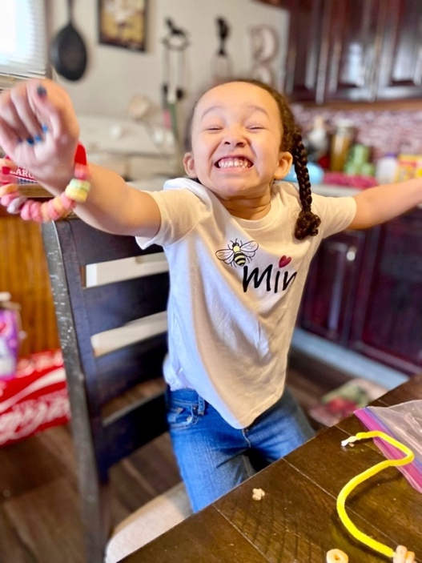
Supporting Transitions
Transition is a major life change that requires a period of adjustment. In the context of school readiness, this transition can be both an exciting and challenging time for the child and family. The Head Start/Early Head Start staff believes in a team approach so the child and family feel supported and have the information that they need to make a successful transition to their next school experience.

Strategies that are currently being implemented by the program to support successful transition practices include a transition plan, family input on all transition surveys, transition visits to new classrooms and kindergartens, Kindergarten fair, and monthly meetings to ensure timely and successful transitions. These are only a few of the activities that we provide for our children and families to be comfortable and have success with all transitions throughout our program.

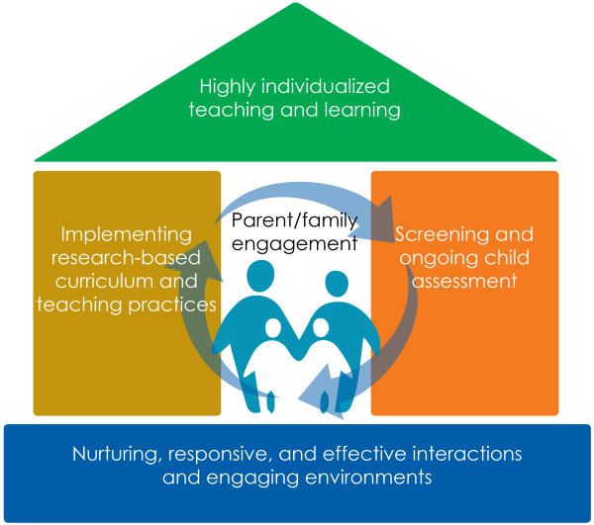

High Quality Teaching and Learning
Head Start and Early Head Start programs are required to ensure that at least 10% of enrollment slots are occupied by children with disabilities. We work closely with local school districts and early intervention programs to ensure the children receive all services that they qualify for under their Individual Family Service Plan or Individual Education program. Head Start served 29 children (10.2%) with an IEP and Early Head Start served 20 (10.4%) children with an IFSP.

Scioto County CAO Head Start follows the Creative Curriculum model. Creative Curriculum allows for the things we feel are most important to our children and families. First, parents are their children’s first teachers. We want parents to be involved with their child’s education and to have input into what their child is learning in the classroom. Second, we believe that each child is an individual and his or her experience should reflect that. The Creative Curriculum supports both beliefs.
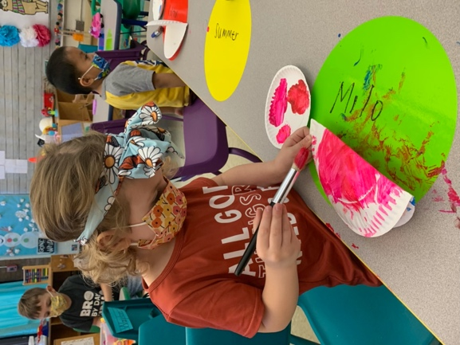
The Early Head Start classroom uses the Creative Curriculum. Early Head Start home base follows Parents as Teachers (PAT) to serve their families' needs. Early Head Start uses Teaching Strategies Gold for child assessment for planning and helping parents understand and engage their child’s development.
Screenings Teacher’s begin their assessment of children with developmental (Brigance for HS and ASQ for EHS) and social/emotional screens (EDECA). The screens help teachers establish a baseline for each child and alert them to any concerns. Screens are done within forty-five days of first day of attendance in a classroom or with in forty-five days of the first home visit for homebase.

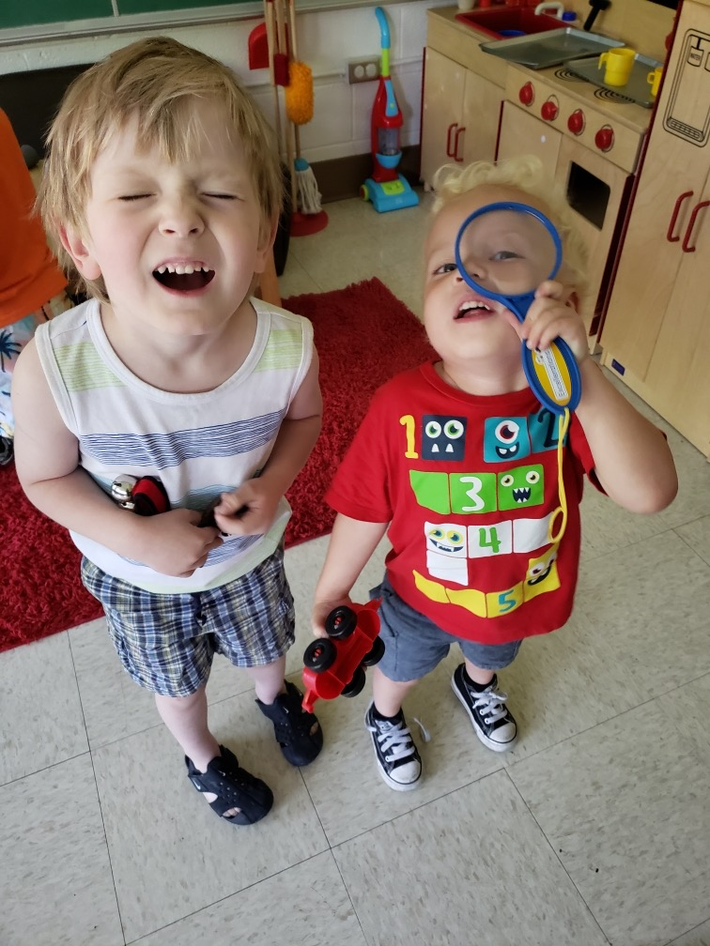
Assessments The Creative Curriculum uses the ongoing cycle of observing, guiding, learning, and assessing children's progress using Teaching Strategies Gold. The child assessment portfolio shows teachers the sequence of steps children takes as they learn skills and concepts in all areas of development. It is a tool for planning instruction and assessing learning. Teaching Strategies Gold aligns with the Ohio Birth to Kindergarten Entry Early Learning and Development Standards and the Federal Head Start Domains.

The Creative Curriculum guides teachers in planning a program that includes choice time, small- and large-group time, and studies that integrates learning across all the content areas. When teachers are up to date on research, they know what to do and why certain teaching strategies work. In turn, they can make decisions that promote learning and development and positively impact the lives of children and their families
For classroom monitoring and support, supervisors use a variety of the following tools: Classroom Assessment Scoring System (CLASS) measures teacher’s interactions, Active Supervision Checklist, Infant/Toddler Environment Rating Scale (ITERS) is a classroom environment checklist and Step Up to Quality (SUTQ) provides self-assessment and oversight for state inspections. Assessments are conducted twice a year. After an assessment is completed, the results are reviewed with the teacher and goals are made to help teachers improve their teaching practices and the quality of instruction in the classroom.
Supporting Staff During the past year one of our priorities was supporting our staff’s physical and mental well-being. As a social service we provide our staff the same resources and programs that we provide the families in our program. We also provided staff with sanitizing products, equipment to be successful with virtual learning including tripods and recording equipment.

Family and Community Engagement
Scioto County CAO Head Start believes that parents are their child’s first teacher and that we are an integral part of connecting families with community resources. Our goal to build a relationship with each child and family that we serve and in turn a larger school community.
During orientation with a HS/EHS family, the family is given a Parent Information Handbook. In addition to our Mission Statement and other general information about the program, it explains the program’s Philosophy of Education that includes HS/EHS Domains of Development and the School Readiness Goals. Families are kept aware of the School Readiness Goals and activities the family can do with their child in the monthly Newsletter with a Family Activity page that states the goal and activity suggestions to achieve the goal, a Monthly Learning Calendar that has daily activities to do with their child that are derived from School Readiness Goals, and PROJECT READ that encourages parents to read and list at least twenty books per month. Fit Families encourage parents to move with their children daily through simple task like housekeeping or grocery shopping to more planned activities like taking a walk or playing outside.

We offered our families the opportunity for a Christmas drive around at our main Head Start campus. The evening event was lit up with Christmas lights and decorations. Staff social distanced and wore mask while stuffing our families’ stockings with fruit, fine motor toys as well as books and information for family wellness. The families were also given the opportunity to have pictures taken with Santa and receive them as they exited the drive around. This was one of several events we held as a drive-through event providing time to build relationships and community with families while maintaining Covid protocols.
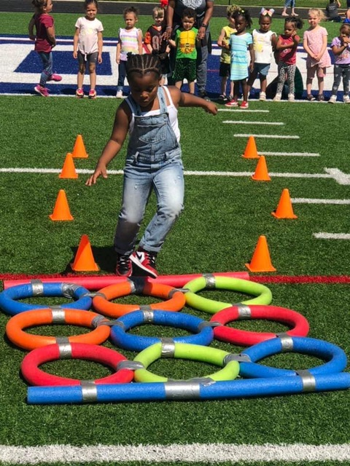
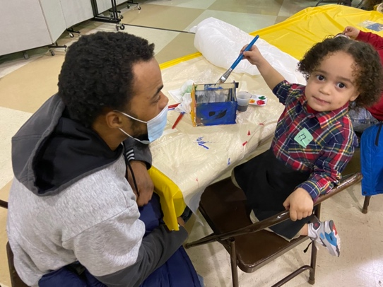
Parent/Family Volunteer Hours
Month Hours

July 2021 1,953
August 2021 2,038
September 2021 2,960
October 2021 3,244
November 2021 3,738
December 2021 2,748
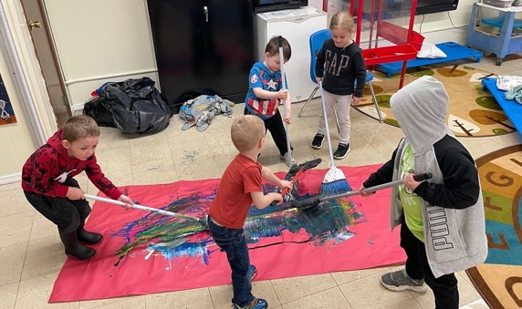
January 2022 2,969
February 2022 3,391
March 2022 4,500
April 2022 3,344
May 2022 3,440
June 2022 2,405
TOTAL 36,730

On-going Initiatives

Conscious Discipline
We are continuing our Conscious Discipline journey. Conscious Discipline is a comprehensive classroom management and a social-emotional curriculum. It is based on brain research, child development, and developmentally appropriate practices. Conscious Discipline has been specifically designed to make changes in the lives of adults first. The adults, in turn, change the lives of children. Most staff members have completed at least 40 hours of training. We have continued to offer on-line trainings throughout the pandemic and feel that our staff’s CD training has helped them and the families they serve cope with stress and concerns of the past two years. In August 2022 we will offer 16 hours in-person training to all Head Start/Early Head Start staff.

Cooking Live with WIC
The CAO Head Start program and WIC program teamed up to partner with the Scioto County OSU Extension Office to provide a nutrition program through social media. The number of pre-school families that use their WIC card has decreased in Scioto County. The intent of the collaboration is to have families make meals that are nutritious and family friendly from ingredients that are on the WIC eligibility list, with the hope that more families would use their cards or sign up for the WIC program. The group shares the recipe and the groceries obtained from the WIC list. The meal is then cooked before a live audience on Facebook Live. Families learn how to prep for the meal, follow a recipe and learn some kitchen tricks. The live videos are intended to encourage WIC participation while educating our families on healthy meal preparation, the cost effectiveness of using your WIC dollars and eating with your family. Families were also introduced to the WIC app for their phone and showed how to use it to identify WIC eligible food while shopping.

Safe Baby Court program and TIP (Therapeutic Interagency Program).
Our program is a part of our county Safe Baby Court program and TIP (Therapeutic Interagency Program). These teams are composed of many agencies which include: SOMC Social Work& Maternity, Dr. Mikel Rase, Shawnee Family Health Center, CAO Head Start/Early Head Start, Help Me Grow, Children Services, Scioto County Juvenile Court, and Scioto County Board of Developmental Disabilities. The children that benefit from these programs are children ages birth through five with a history of pre- and post-natal exposure to substance abuse, child psychological trauma and/or abuse/neglect. This interagency collaboration and communication make a positive impact on these families in our community. We are proud to be associated with both groups by providing quality services and support to these families and children in our community.

Nationwide Children’s Hospital Dental Clinic
Head Start/ Early Head Start collaborated with Nationwide Children’s Dental clinic to provide free dental screenings, oral exams, and application of fluoride to enrolled children for the 2021-2022 school year . There were 142 children seen by the team of Homa Amini DDS, Rosa Ortega DDS and Beth Noel RDH at Highland Head Start building. Each child received a take home bag with toothpaste, toothbrush, and a dental education sheet.
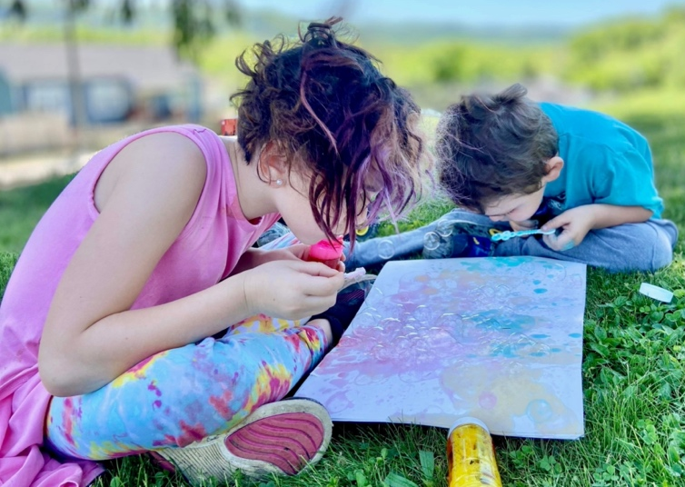
Financial Report
Community Action Organization of Scioto County submitted the grant application for Head Start and Early Head Start for funding year 2021-2022 for 422 children, in the amount of $6,271,325.00. The funding covered the period from July 1, 2021 through October 31, 2022. Our budget period was extended four months to get us back to our scheduled November 1 grant start date.

Head Start/Early Head Start submitted a supplemental 2.28% COLA application in May 2022, which will be rolled into our refunding application. This increase was received in June 2021. Head Start did receive a State ECE grant of $212,000 to serve 53 children for the 2021-2022 school year, which will be used to blend Head Start and ECE services for children. The program will also receive approximately $140,000 in CACFP funds for meals.

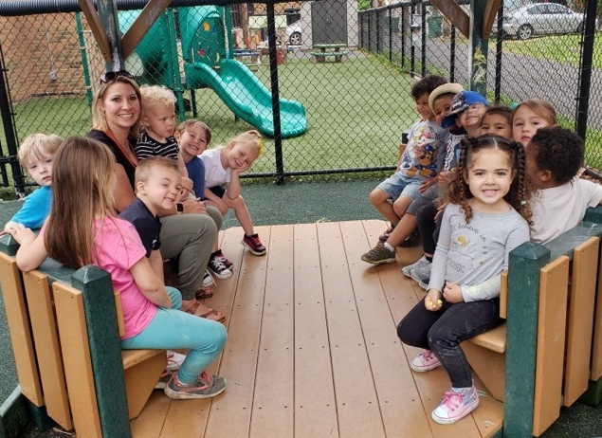
Tidwell Group completed our audit. The audit findings were released in August 2021 with no findings. The 2022 audit will be released in August 2022.

The grant has finished its second year of the five-year cycle and includes completion of Long-Range Goals and Short-term Objectives, School Readiness Goals, and Program Impacts. It includes needs of children and families, service areas, different available program options, family and social services, along with transportation, educational and health issues. Child Assessment Data, Curriculum and the progress on Staff-Child Interaction Observation data (CLASS scores) is also included. Parent, Family and Community Engagement Goals and objectives along with the methods of gathering data are included.

Community Action Organization of Scioto County
Head Start/Early Head Start Refunding Application
July 1, 2021 – October 31, 2022
 | HS Operating | HS Training | EHS Operating | EHS Training | HS In-kind | EHS In-kind | Total
Salary | $1,945,107 | $0 | $890,054 | $0 | $387,036 | $387,036 | $3,222,197
Fringe | $820,398 | $0 | $291,469 | $0 | $0 | $0 | $1,111,867
Equipment | $60,000 | $0 | $30,000 | $0 | $0 | $0 | $90,000
Travel | $0 | $15,224 | $0 | $15,282 | $0 | $0 | $30,506
Supplies | $74,830 | $0 | $44,050 | $0 | $136,641 | $89,380 | $344,901
Contractual | $67,200 | $11,771 | $16,950 | $4,153 | $0 | $0 | $100,074
Other Costs | $243,771 | $11,673 | $76,867 | $12,242 | $356,434 | $284,775 | $985,762
Indirect | $270,366 | $0 | $115,553 | $0 | $0 | $0 | $386,019
Total | $3,481,772 | $38,668 | $1,464,943 | $31,677 | $880,110 | $374,155 | $6,271,325

